NASA Administrator Nelson travel to Japan/Kyoto
Dialogue with NASA Administrator Bill Nelson, 14th administrator of the National Aeronautics and Space Administration

Organizer, SIC Human Spaceology Center, GSAIS, Kyoto University
Co-organizer, Kyoto University Unit of Synergetic Studies for Space
Date 11 February 2023 11:00 – 12:00
Venue: Symposium Hall (5F), International Science Innovation Building, Kyoto University
https://www.saci.kyoto-u.ac.jp/en/innovation/facility/
https://www.saci.kyoto-u.ac.jp/en/access/

Program
11:00-11:20 Lecture by Senator Nelson
11:20-12:00 Question & comments
Closing
Chaired by Professor Takao Doi, Astronaut
Translation made by Professor Yosuke A. Yamashiki

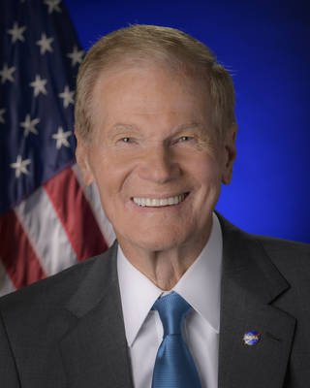
NASA Administrator Bill Nelson

Nelson chaired the Space and Science Subcommittee in the U.S. House of Representatives for six years and the U.S. Senate for 12 years. He then served as the Ranking Member of the full Senate Commerce, Science, and Transportation Committee. Nelson was recognized as the leading space program advocate in Congress.

In 2010, Nelson and Sen. Kay Bailey Hutchinson (R-Texas) passed the landmark NASA legislation that mapped out a new future for NASA and set the agency on its present dual course of both government and commercial missions. In 2017, Nelson and Sen. Ted Cruz (R-Texas) authored the NASA Transition Authorization Act of 2017, which expanded NASA’s commercial activities in space.

During his time in Congress, Nelson was a strong advocate for NASA’s Earth science programs and authored numerous pieces of legislation to combat and mitigate the effects of climate change. Nelson was also a vocal proponent for STEM career training and education programs to create and fill the jobs of the future.

In 1986 he flew on the 24th flight of the Space Shuttle. The mission on Columbia orbited the earth 98 times over six days. Nelson conducted 12 medical experiments including the first American stress test in space and a cancer research experiment sponsored by university researchers.

Nelson has served in public office over four decades, first in the state legislature and U.S. Congress, then as State Treasurer. He was elected three times to the United States Senate, representing Florida for 18 years. His committees included the breadth of government policy from defense, intelligence and foreign policy to finance, commerce, and health care.

From president of 4-H to international president of the Key Club in high school, Nelson has always known the importance of investing in your neighbors and community to create a better future. Nelson continued to serve his community and country while in college at the University of Florida, Yale, and University of Virginia Law School through various service organizations, school leadership positions. He served on active duty as a Captain in the U.S. Army.

In 1971, Nelson met Grace Cavert of Jacksonville, Florida, while speaking at a statewide young leader convention. Grace has been an active partner in Bill’s public service career. From his first race for a seat in the Florida Legislature, Grace has been by his side knocking on doors and talking to folks about issues that mattered to them and their families. They have two grown children, Bill Jr. and Nan Ellen.
SIC Human Spaceology Center 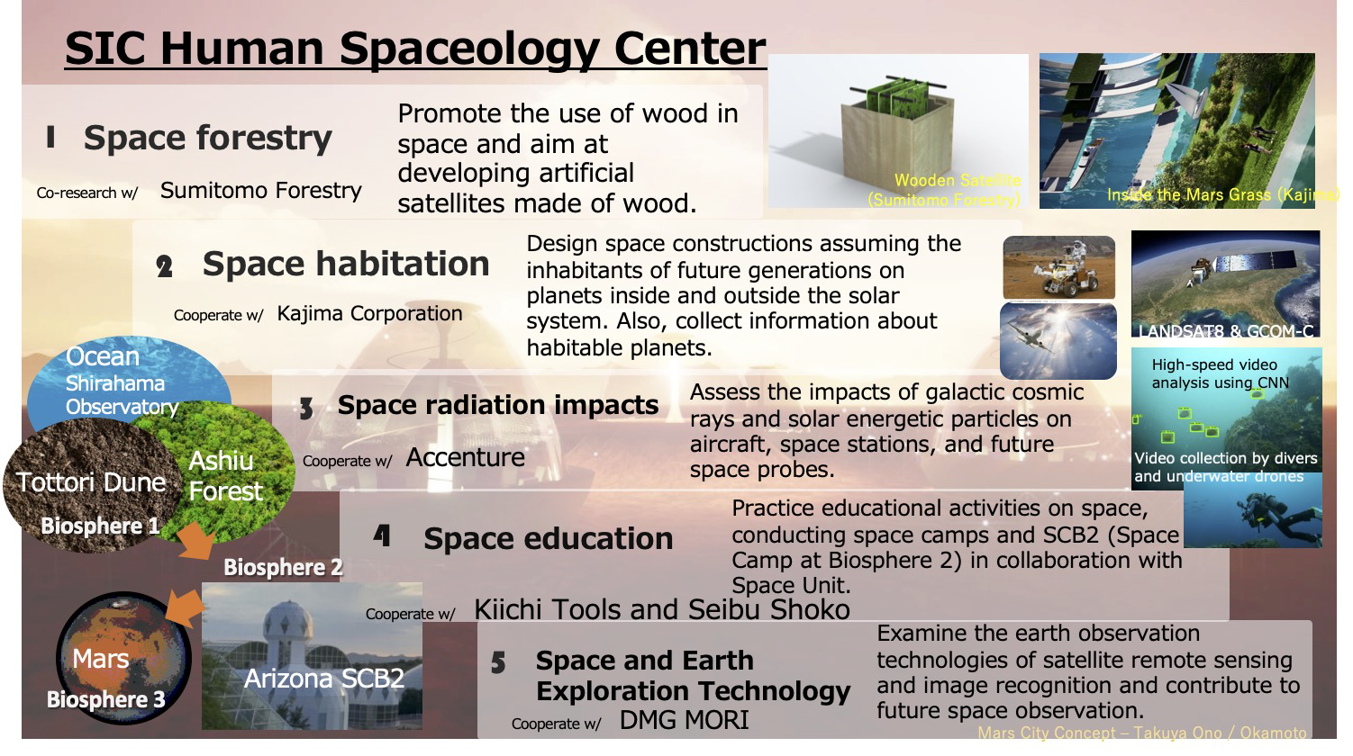
SIC Human Spaceology Center was established in 2021 as a satellite-center of Social Innovation Center (SIC) - Graduate School of Advanced Integrated Studies in Human Survivability(GSAIS), Kyoto University, consisted with five research field, Space forestry, Space habitation, Space radiation impacts, Space education, and Space and earth exploration technologies, by collaborating astronauts experienced in manned space activities, researchers from NASA, JAXA, JAEA, and private sectors.
When we discuss the future survival of generations of human beings, we must not avoid discussing humanity’s advancement into space. Humans should be maintaining the environment on Earth, but at the same time, we need to develop strategies for new habitation possibilities in space. SIC Spaceology Center will develop and evaluate “core technologies” for human advancement into space And we aim to build a sustainable “core society” based on “core-biome” concept.
Core members
Yosuke Yamashiki *SHuman Spaceology Center Director, Professor
Takao Doi Special Professor, Astronaut
Vladimir Airapetian SIC Specially Appointed Professor, NASA/GSFC
Yoshifumi Inatani SIC Specially Appointed Professor, JAXA/ISAS
Yuko Inatomi SIC Specially Appointed Professor, JAXA/ISAS
Tatsuhiko Sato SIC Specially Appointed Professor, JAEA
Naoko Yamazaki Specially Appointed Associate Professor, Astronaut
Takuya Ohno SIC Specially Appointed Associate Professor, Kajima Co. Ltd.
Daikichi Seki Affiliate Researcher, Kyushu University
ビル・ネルソンNASA長官と京都の大学生との交流会
日時 2023年2月11日 11:00-12:00
参加可能な人 京都在住（もしくは周辺）の学生*
*中学生・高校生・大学生・大学院生
*簡単な通訳は行いますが、英会話が可能な人

ビル・ネルソン上院議員、NASA長官

2021年5月3日、ビル・ネルソン上院議員は、バイデン＝ハリス政権が掲げるNASAのビジョンを遂行することを任務とし、第14代NASA長官に就任した。
1986年には、スペースシャトルの24回目の飛行に参加し、6日間で98回、地球を周回した。2010年には、ネルソン氏は、NASAを政府と民間の両方のミッションからなる現在のデュアルコースに設定する画期的なNASA法案を可決した。また、これまで、米国下院で6年間、上院で12年間、宇宙科学小委員会の委員長を務め、その後、上院の商業・科学・運輸委員会の委員長を務め、議会における宇宙開発計画を主導してきた。2017年には、NASAの宇宙での商業活動を拡大する「2017年NASA移行認可法」を起草した。議員時代からネルソンはNASAの地球科学プログラムを先導し、気候変動の影響に対抗し緩和するための数多くの法案を提出した。さらに、将来の雇用を創出するため、STEMキャリア訓練および教育プログラムの声高な推進者でもあった。

SIC有人宇宙学研究センター
人類の未来世代における生存を議論する上で、人類の宇宙進出についての議論は避けることができない。人類は良好な地球環境の維持に努めるとともに、新たな宇宙空間における居住可能性について戦略を持って進めてゆく必要がある。
2021年に、大学院総合生存学館ソーシャルイノベーションセンターの一領域として設立され、宇宙木材研究、宇宙居住研究、宇宙放射線研究、宇宙教育研究、宇宙・地球探査技術研究の５つの研究領域を基軸として、有人宇宙活動経験者や、宇宙開発経験者、そしてNASA/JAXA/JAEA研究員をコアメンバーとする。
当センターでは、宇宙空間における人類進出のために「有人宇宙学-コアバイオームコンセプト」を確立し、宇宙移住のための「基幹技術-コアテクノロジー」の開発と評価を行う。そして、近未来における持続可能な「宇宙社会-コアソサエティ」の構築を目指す。
